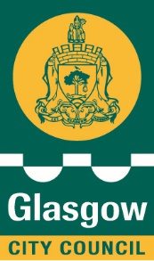
COMMUNITY EMPOWERMENT (SCOTLAND) ACT 2015
STATUTORY CONSULTATION NOTICE
PROPOSED DEMOLITION OF THE EAST
BOATHOUSE GLASGOW GREEN
Consultation dates: commences 25th November to 7th January 2026
Why are we consulting?
Under Part 8 of the Community Empowerment (Scotland) Act 2015, Local Authorities are required to carry out a consultation exercise when seeking to change the use, or dispose of, any properties forming part of the Common Good. Glasgow City Council is proposing to demolish a building, East Boathouse in Glasgow Green. This land forms part of the Council’s Common Good assets. Representations are, therefore, being sought in respect of the proposed demolition.
Further information on Common Good, and the obligations on Local Authorities under the Community Empowerment (Scotland) Act 2015, can be found on the Council’s website.
https://www.glasgow.gov.uk/index.aspx?articleid=24074
What is being proposed?
This property has been used as a Boathouse and had previously been leased to organisations to store equipment and access the river. The building is no longer in a usable condition and is at risk of structural collapse due to the condition of the building structure and instability of the riverbank the building is situated upon. Due to safety concerns it is considered sensible to demolish the building and make the area safe.
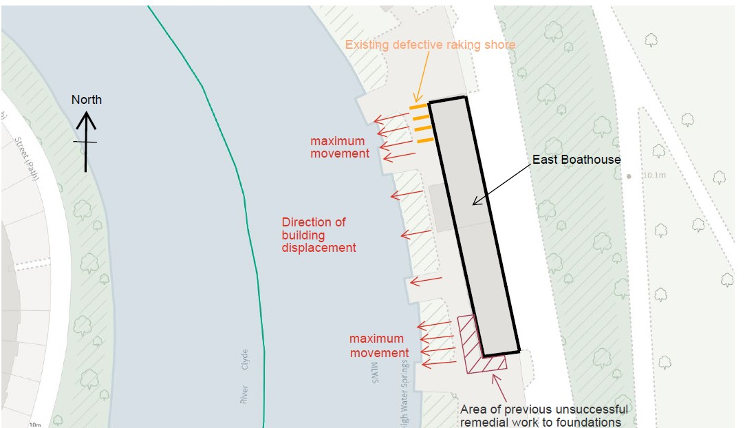
Representations
If you have any comments or representations to make on the proposal, these can be made by email or letter or by completing the box below and returning the form to Glasgow City Council at the addresses given below. Responses must arrive by 7th January 2026 :-

Emails responses to be sent to: commongoodconsultation@glasgow.gov.uk
Postal responses to be sent to: Corporate and Property Law Section, Chief Executive’s Department, Glasgow City Council, City Chambers, George Square, Glasgow, G2 1DU.

What happens next?

Glasgow City Council will consider and respond to any representations within weeks of the consultation closing date. The Council’s final response will be published on the Council’s website along with details of all representations to this consultation (excluding address, postcode and email of respondent, and in line with our Data Protection Policy).

The Council will then take a decision having regard to the outcomes of this Consultation as to whether to proceed with the disposal.

The consultation period ends on 7th January 2026 .

